Name : Nauval Shafiq

Applied for : Test Engineer

**Basic Programming**

**Answer:**

1. The data-types that usually used in arithmetic operation are integer (consist of: int, byte, long, short) and floating-point (consist of: float and double)
2. 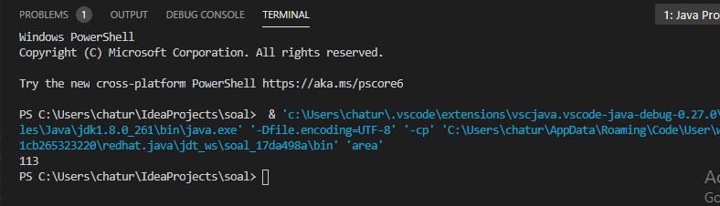The data-types that usually used in word and character are char and String
3. The result is 113
4. The result is 2

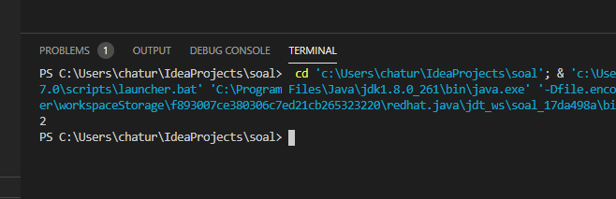

1. The result is 3566GoldenStreetMiami

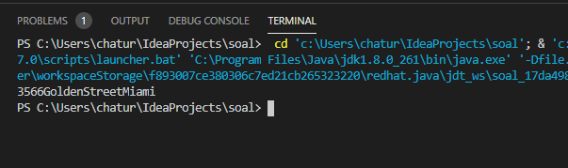

**Flaky Test**

**Answer**

1. Flaky test is a test that could be fail or pass in a same configuration or environment. When flaky test is occurred, it could harm the developer because we cannot see if a test is failure because of bugs or something else.
2. F
3. As far as I know, we cannot fully do an automation testing on a page that contains captcha because the purpose of captcha is to differentiate between real human and robot. To do the test, we can ask the developer the workaround access or backdoor to pass the captcha page, or if the captcha is generated by an end-point, we can access the endpoint using GET request. Another ways to do it is by do a fully automation as usual, but when the step is on input captcha page, tester input the captcha manually.